**Homework 4**

**Instructions:** Do as many of the problems as you like, but make sure to complete at least **three**. Then I will create a solution from your work.

1. Find two other famous number theory conjectures. Briefly describe what the conjecture says and add any information about the current status of the work on this conjecture.
2. Find the prime factorization of 185803 by hand. (Briefly explain your method for finding the prime factorization.)
3. Show that there are infinitely many prime numbers of the form $3n+2.$ (The same idea applies for prime numbers of the form $6n+5.$)
4. Show that the binomial coefficient [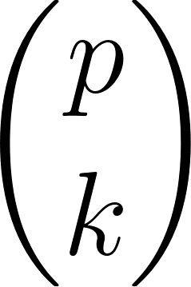](https://www.codecogs.com/eqnedit.php?latex=%5Cbinom%7Bp%7D%7Bk%7D#0) is divisible by *p* if *p* is prime and $1≤k<p.$
5. Let $p_{n}$ be the *n*th prime number.
6. Show that $p_{n}≤p_{1} p_{2} ⋅⋅⋅p_{n-1}+1.$
7. Use part a. to show that $p_{n}<{2^{2}}^{n}.$ (Hint: Use induction.)
8. Write a code to implement the Eratosthenes Sieve to create the list of all primes up to *n* for given *n*.